**OPERATING SYSTEMS**

**ASSIGNMENT 8**

**NAME : T Karthikeyan**

**ROLL : CED18I064**

**All my codes can be found here** [**CLICK HERE**](https://drive.google.com/drive/folders/1VFwT9s5UjlTyY3Tkyms_3pdwMRd3NMG7?usp=sharing)

1. **Dining Philosophers Problem**

**PROBLEM**

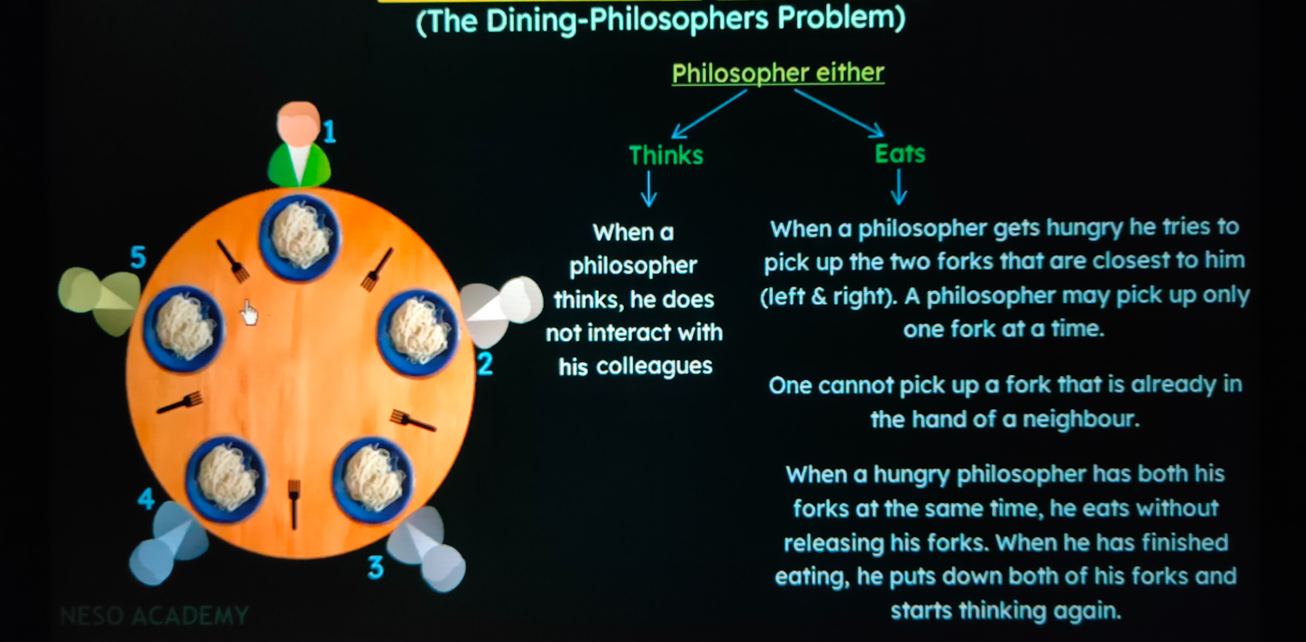

**WORKING**

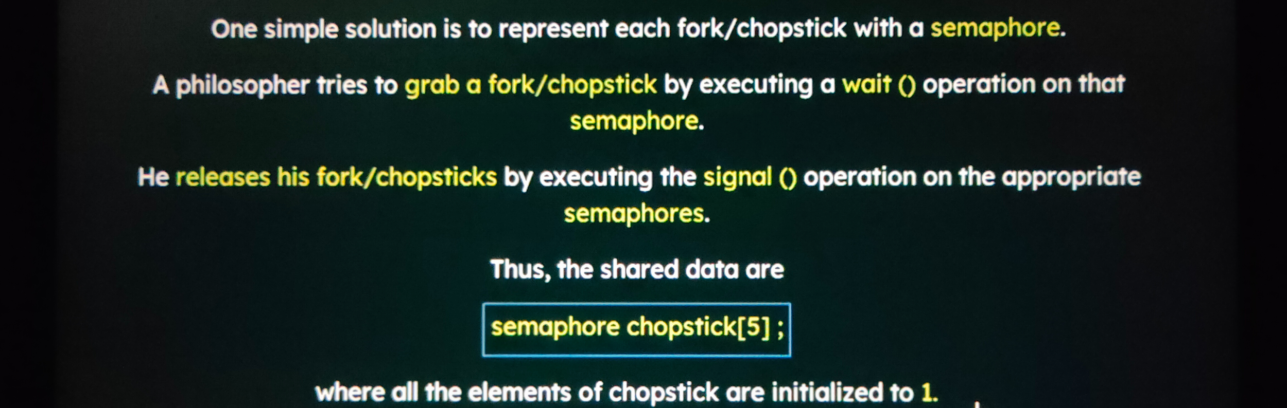

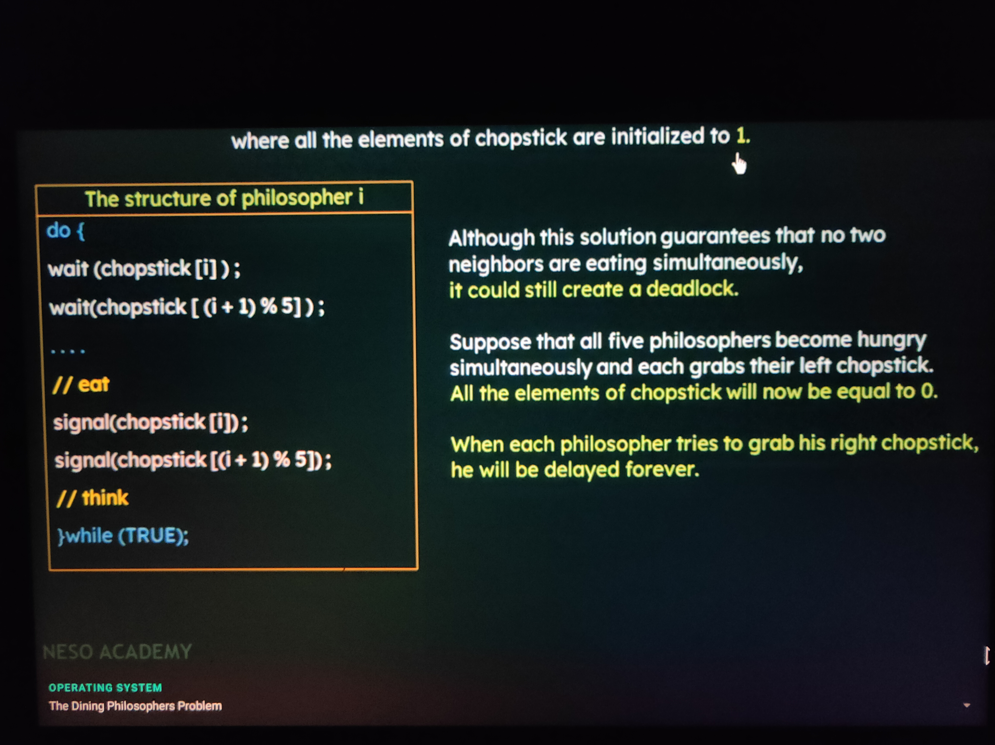

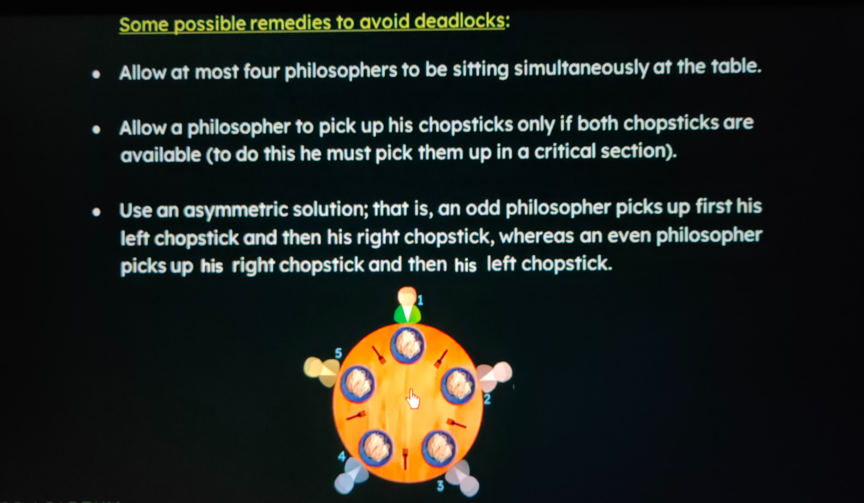

*We will be allowing the philosopher to pick up fork/chopstick only when both are available*

**CODE**

**#include<stdio.h>**

**#include<semaphore.h>**

**#include<pthread.h>**

**#define N 5**

**#define THINKING 0**

**#define HUNGRY 1**

**#define EATING 2**

**#define LEFT (ph_num+4)%N**

**#define RIGHT (ph_num+1)%N**

**sem_t mutex;**

**sem_t S[N];**

**void *philosopher(void *num);**

**void take_fork(int);**

**void put_fork(int);**

**void test(int);**

**int state[N];**

**int phil_num[N] = {0, 1, 2, 3, 4};**

**int main()**

**{**

**int i;**

**pthread_t thread_id[N];**

**sem_init(&mutex, 0, 1);**

**for(int i = 0; i < N; i++)**

**sem_init(&S[i], 0, 0);**

**for(int i = 0; i < N; i++)**

**{**

**pthread_create(&thread_id[i], NULL, philosopher, &phil_num[i]);**

**printf("Philosopher %d is thinking\n", i+1);**

**}**

**for(int i = 0; i < N; i++)**

**pthread_join(thread_id[i], NULL);**

**sem_destroy(&mutex);**

**for(int i = 0; i < N; i++)**

**sem_destroy(&S[i]);**

**return 0;**

**}**

**void *philosopher(void *num)**

**{**

**while(1)**

**{**

**int *i = num;**

**sleep(1);**

**take_fork(*i);**

**printf("Philosopher %d has finished eating\n", *i+1);**

**put_fork(*i);**

**}**

**}**

**void take_fork(int ph_num)**

**{**

**sem_wait(&mutex); // so that state update remains critical section**

**state[ph_num] = HUNGRY;**

**printf("Philosopher %d is Hungry\n", ph_num + 1);**

**test(ph_num);**

**sem_post(&mutex);**

**sem_wait(&S[ph_num]);**

**sleep(1);**

**}**

**void test(int ph_num)**

**{**

**if(state[ph_num] == HUNGRY && state[LEFT] != EATING && state[RIGHT] != EATING)**

**{**

**state[ph_num] = EATING;**

**sleep(2);**

**printf("Philosopher %d takes fork %d and %d\n", ph_num + 1, LEFT + 1, ph_num + 1);**

**printf("Philosopher %d is eating\n", ph_num + 1);**

**sem_post(&S[ph_num]);**

**}**

**}**

**void put_fork(int ph_num)**

**{**

**sem_wait(&mutex);**

**state[ph_num] = THINKING;**

**printf("Philosopher %d putting fork %d and %d down\n", ph_num + 1, LEFT + 1, ph_num + 1);**

**printf("Philosopher %d is thinking\n", ph_num + 1);**

**test(LEFT);**

**test(RIGHT);**

**sem_post(&mutex);**

**}**

**OUTPUT**

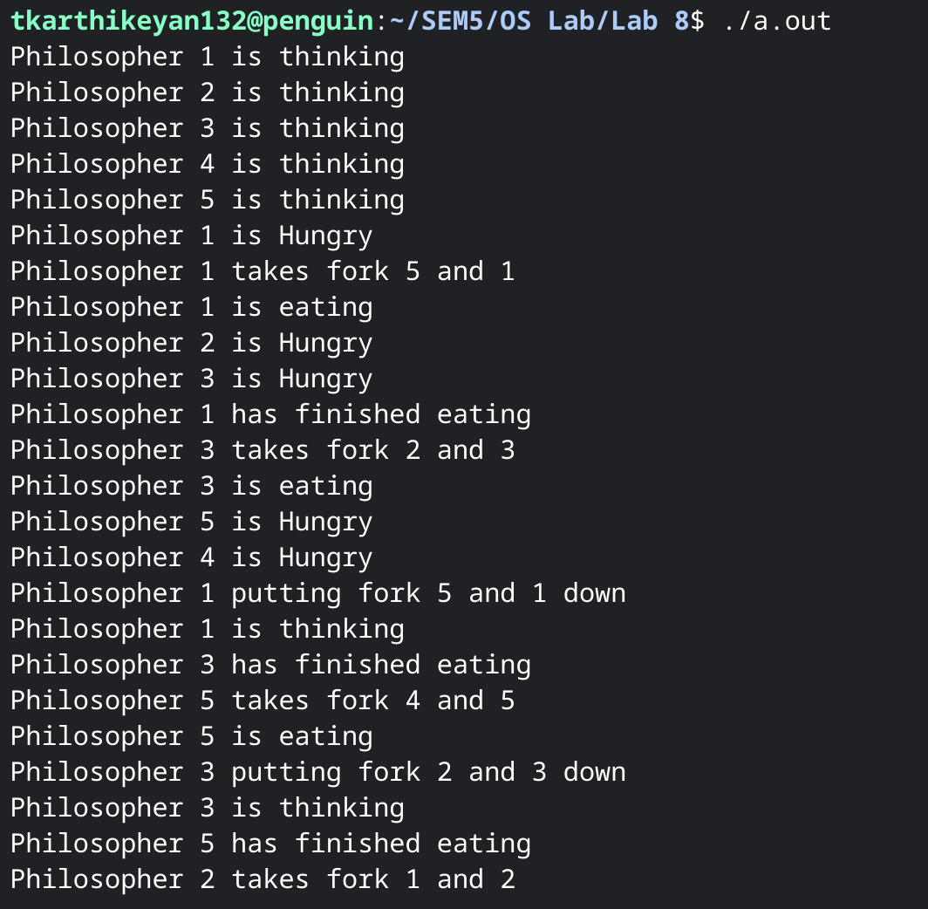

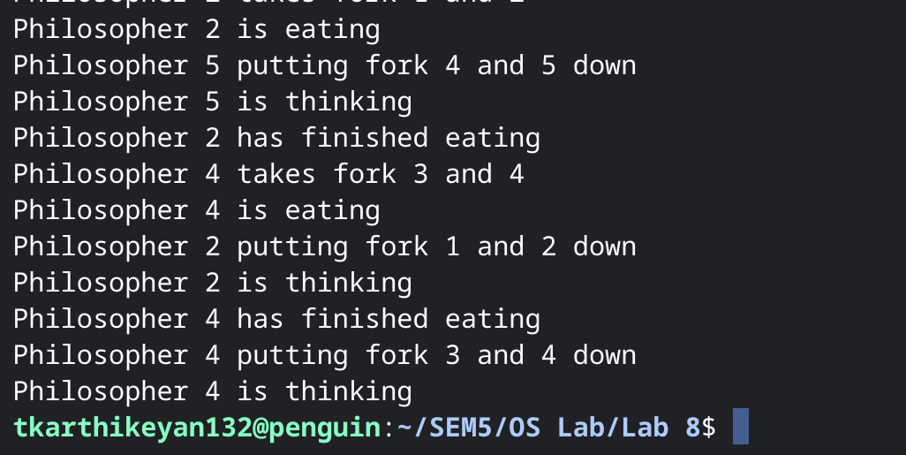

1. **Reader Writers Problem**

**PROBLEM**

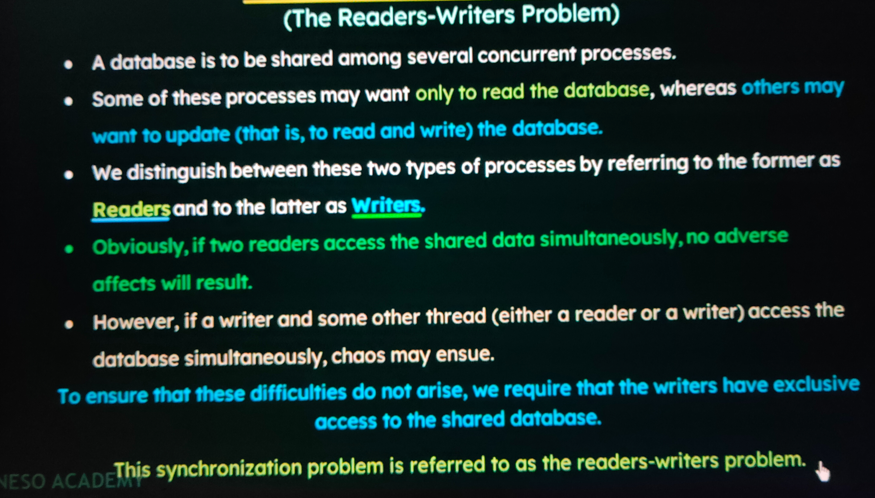

**WORKING**

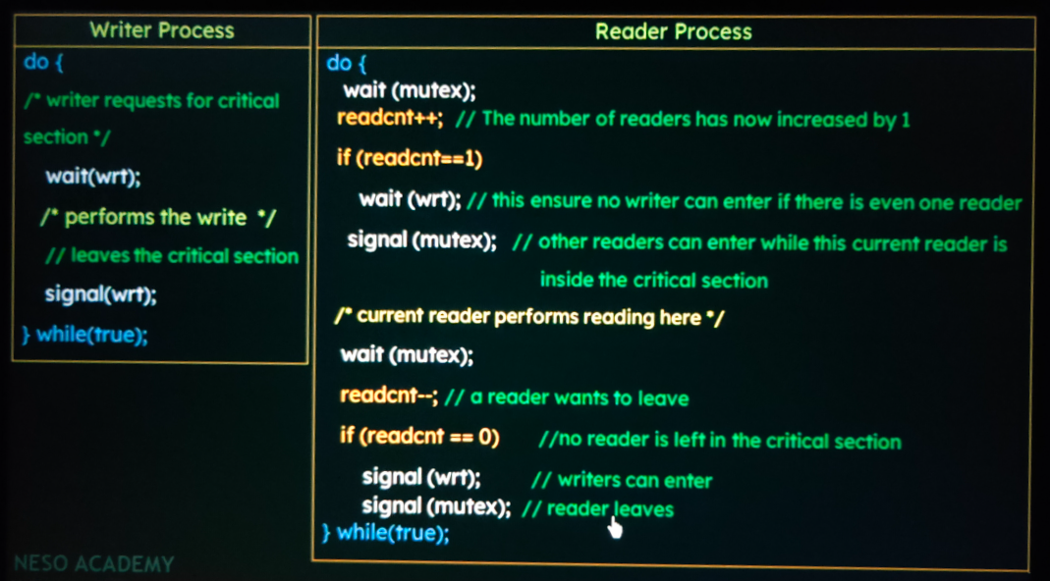

**CODE**

**#include<stdio.h>**

**#include<pthread.h>**

**#include<semaphore.h>**

**sem_t mutex, writeblock;**

**int data = 0, rcount = 0;**

**void *reader(void *arg);**

**void *writer(void *arg);**

**int main()**

**{**

**int i, b;**

**pthread_t rtid[3], wtid[3];**

**sem_init(&mutex, 0, 1);**

**sem_init(&writeblock, 0, 1);**

**int twid[3] = {0,1,2};**

**int trid[3] = {0,1,2};**

**// for(int i = 0; i <= 2; i++)**

**// {**

**pthread_create(&wtid[0], NULL, writer, &twid[0]);**

**pthread_create(&wtid[1], NULL, writer, &twid[1]);**

**pthread_create(&wtid[2], NULL, writer, &twid[2]);**

**pthread_create(&rtid[0], NULL, reader, &trid[0]);**

**pthread_create(&rtid[1], NULL, reader, &trid[1]);**

**pthread_create(&rtid[2], NULL, reader, &trid[2]);**

**// }**

**// for(int i = 0; i <= 2; i++)**

**// {**

**pthread_join(wtid[0], NULL);**

**pthread_join(rtid[0], NULL);**

**pthread_join(wtid[1], NULL);**

**pthread_join(rtid[1], NULL);**

**pthread_join(wtid[2], NULL);**

**pthread_join(rtid[2], NULL);**

**// }**

**sem_destroy(&mutex);**

**sem_destroy(&writeblock);**

**return 0;**

**}**

**void *reader(void *arg)**

**{**

**int *f;**

**f = arg;**

**sem_wait(&mutex);**

**rcount = rcount + 1;**

**if(rcount == 1) // first reader**

**sem_wait(&writeblock);**

**sem_post(&mutex);**

**printf("Data read by the reader %d is %d\n", *f, data);**

**sem_wait(&mutex);**

**rcount = rcount - 1;**

**if(rcount == 0) // last reader**

**sem_post(&writeblock);**

**sleep(3);**

**sem_post(&mutex);**

**}**

**void *writer(void *arg)**

**{**

**int *f;**

**f = arg;**

**sem_wait(&writeblock);**

**data++;**

**printf("Data written by the writer %d is %d\n", *f, data);**

**sleep(3);**

**sem_post(&writeblock);**

**}**

**OUTPUT**

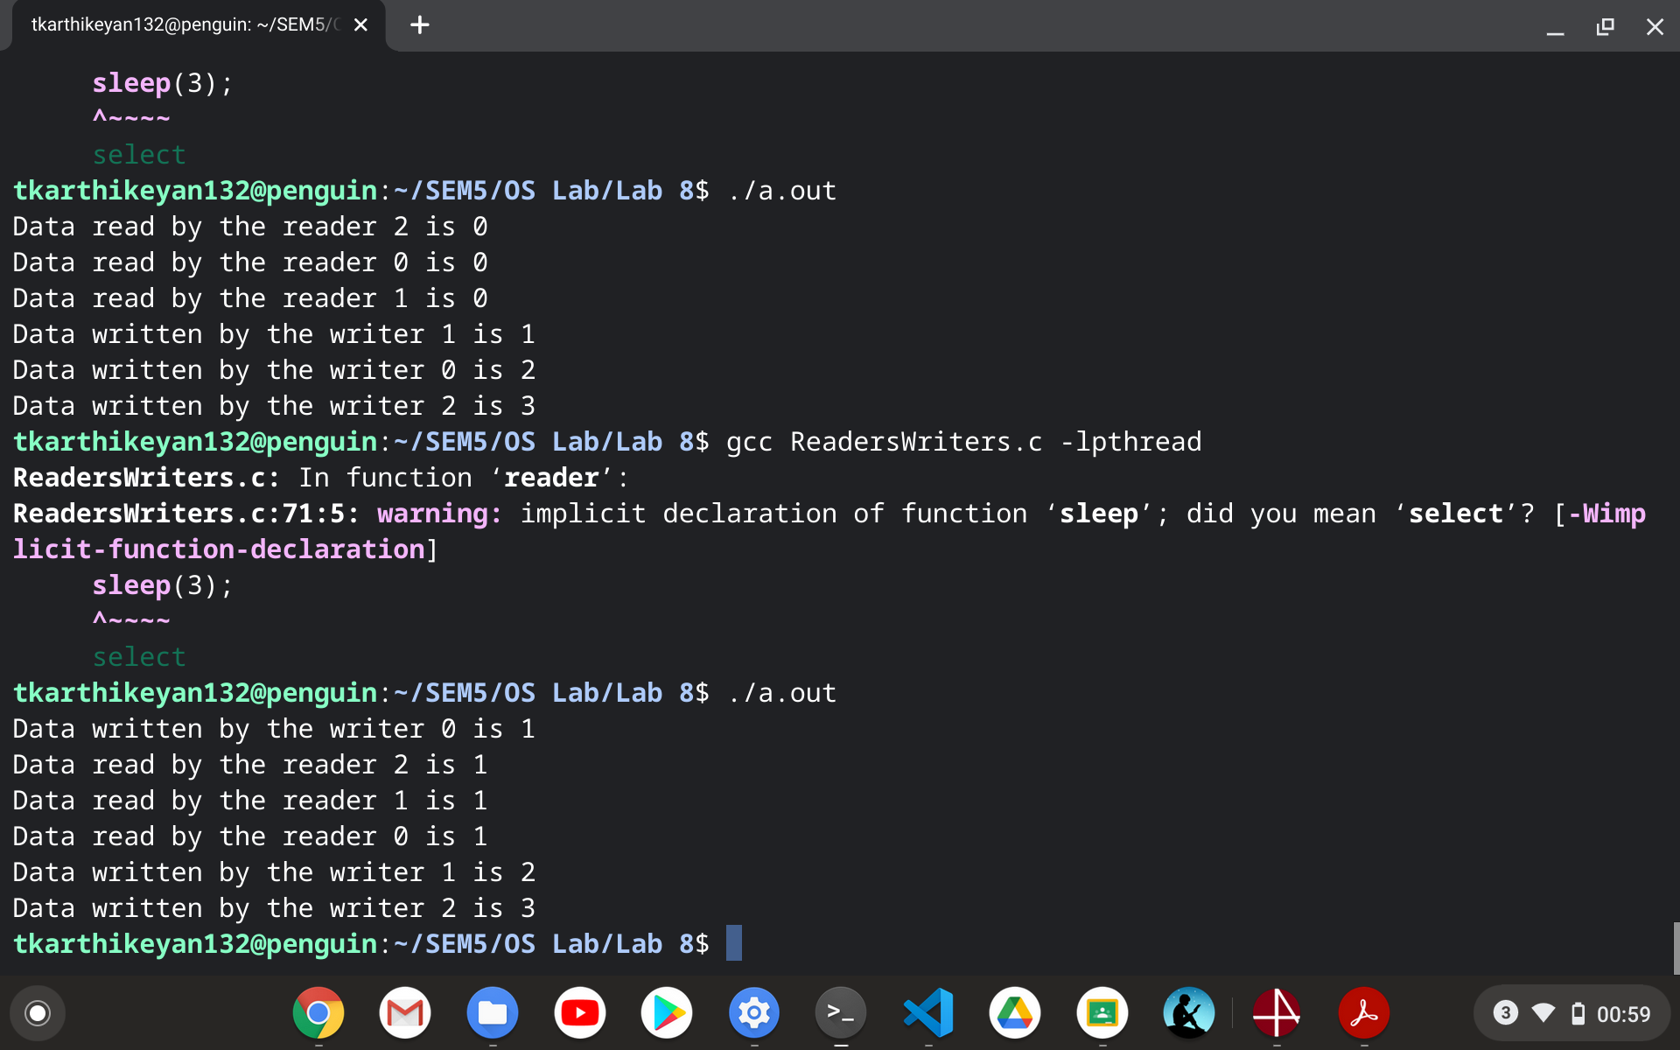

1. **Dining Hall Problem**

**PROBLEM**

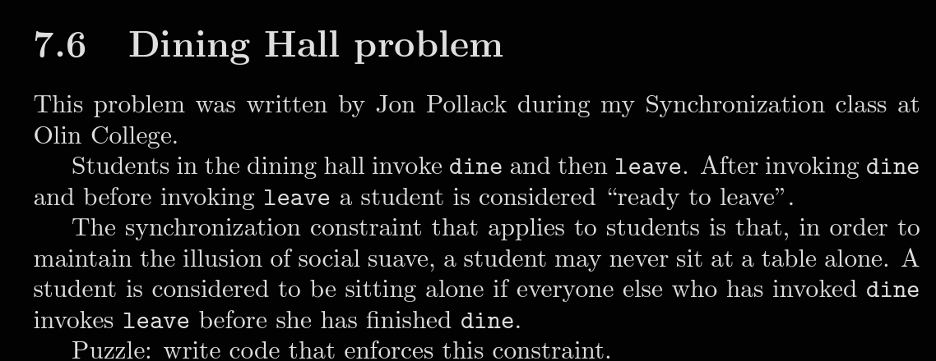

**PSEUDOCODE AND LOGIC**

*eating and readyToLeave are counters protected by mutex, so this is the usual scoreboard pattern. If a student is ready to leave, but another student would be left alone at the table, she waits on okToLeave until another student changes the situation and signals.*

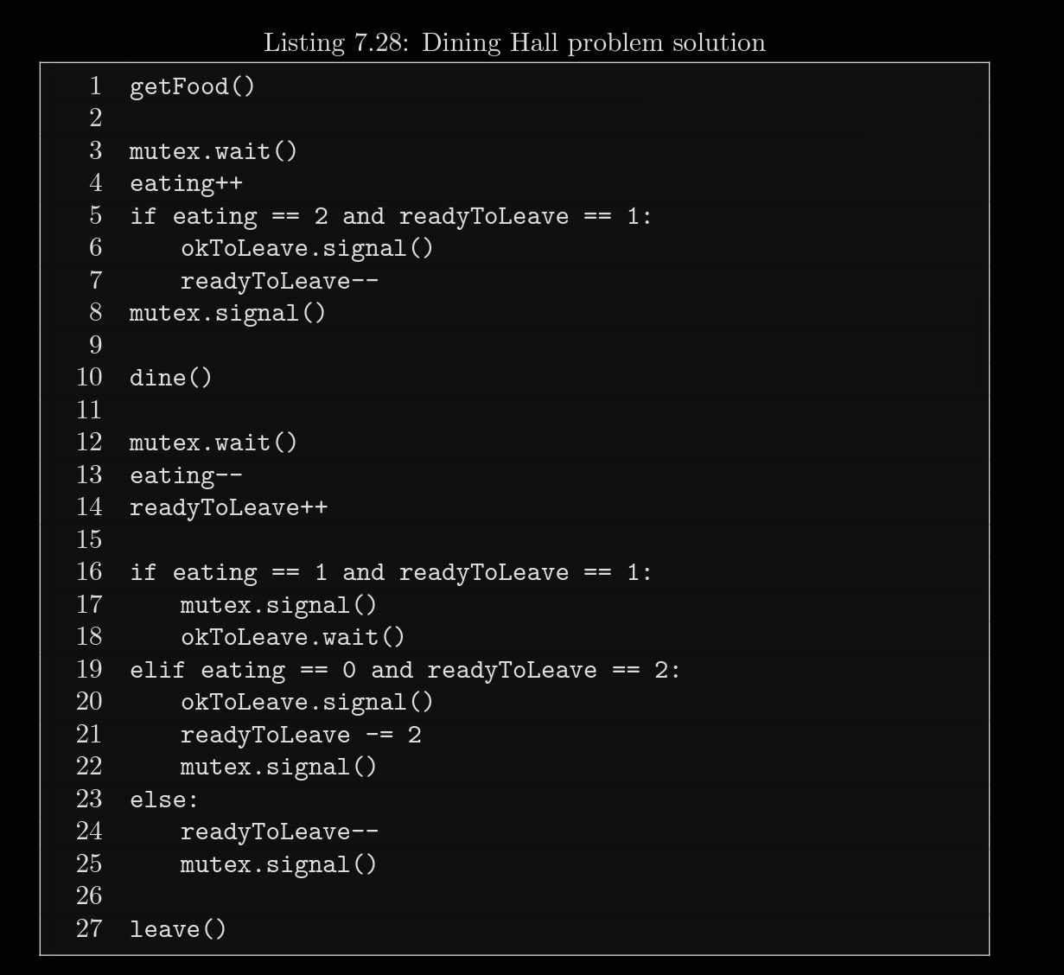

*When a student is checking in, if she sees one student eating and one waiting to leave, she lets the waiter off the hook and decrements readyToLeave for him.*

*After dining, the student checks three cases:*

*• If there is only one student left eating, the departing student has to give up the mutex and wait.*

*• If the departing student finds that someone is waiting for her, she signals him and updates the counter for both of them.*

*• Otherwise, she just decrements readyToLeave and leaves.*

**CODE**

**#include<stdlib.h>**

**#include<stdio.h>**

**#include<stdbool.h>**

**#include<pthread.h>**

**#include<semaphore.h>**

**#define DINING_CAPACITY 5**

**int eating = 0;**

**int readyToLeave = 0;**

**sem_t mutex, okToLeave;**

**void *dine(void *param);**

**int main()**

**{**

**pthread_t tid[DINING_CAPACITY];**

**sem_init(&mutex, 0, 1);**

**sem_init(&okToLeave, 0, 0);**

**int tempid[DINING_CAPACITY];**

**for(int i = 0; i < DINING_CAPACITY; i++)**

**tempid[i] = i + 1;**

**for(int i = 0; i < DINING_CAPACITY; i++)**

**pthread_create(&tid[i], NULL, dine, &tempid[i]);**

**for(int i = 0; i < DINING_CAPACITY; i++)**

**pthread_join(tid[i], NULL);**

**sem_destroy(&mutex);**

**sem_destroy(&okToLeave);**

**return 0;**

**}**

**void *dine(void *param)**

**{**

**int *f = param;**

**printf("Diner %d entered the dining hall\n", *f);**

**sem_wait(&mutex);**

**eating++;**

**printf("Diner %d is eating\n", *f);**

**if(eating == 2 && readyToLeave == 1)**

**{**

**sem_post(&okToLeave);**

**readyToLeave--;**

**}**

**sem_post(&mutex);**

**sleep(5);**

**sem_wait(&mutex);**

**eating--;**

**readyToLeave++;**

**printf("Diner %d is ready to leave\n", *f);**

**if(eating == 1 && readyToLeave == 1)**

**{**

**sem_post(&mutex);**

**sem_wait(&okToLeave);**

**}**

**else if(eating == 0 && readyToLeave == 2)**

**{**

**sem_post(&okToLeave);**

**readyToLeave-=2;**

**sem_post(&mutex);**

**}**

**else**

**{**

**readyToLeave--;**

**sem_post(&mutex);**

**}**

**printf("Diner %d has left the hall\n", *f);**

**}**

**OUTPUT**

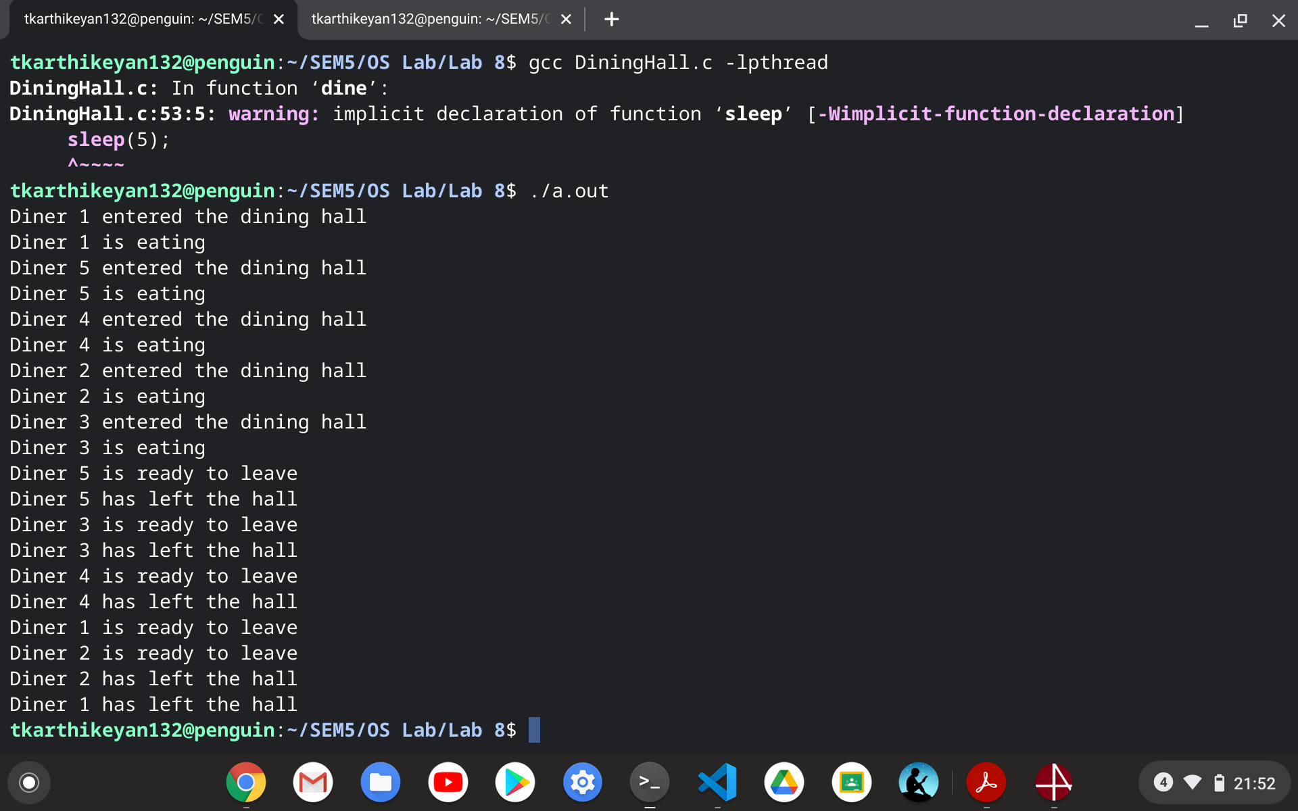

1. **SENATE BUS PROBLEM**

**PROBLEM**

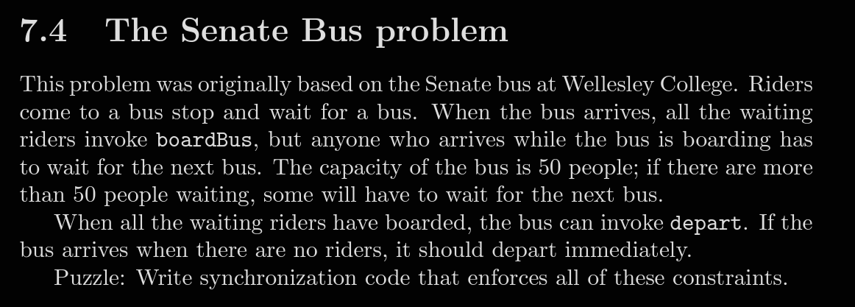

**PSEUDOCODE AND LOGIC**

*mutex protects riders, which keeps track of how many riders are waiting; multiplex makes sure there are no more than 50 riders in the boarding area. Riders wait on the bus, which gets signaled when the bus arrives. The bus waits on allAboard, which gets signaled by the last student to board.*

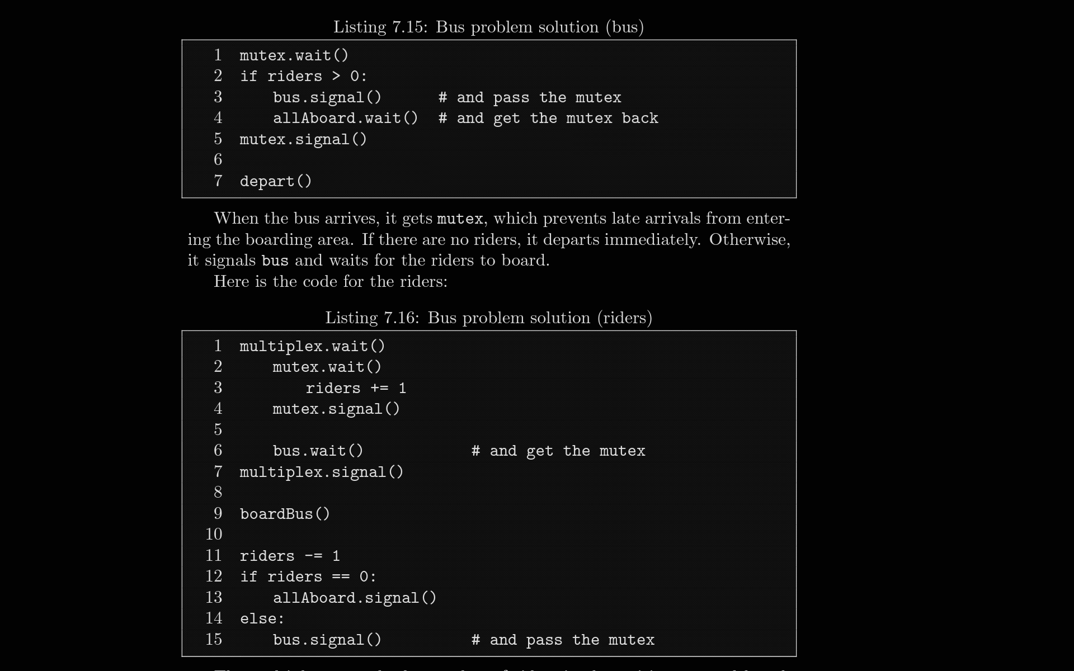

*The multiplex controls the number of riders in the waiting area, although strictly speaking, a rider doesn’t enter the waiting area until she increments riders. Riders wait on the bus until the bus arrives. When a rider wakes up, it is understood that she has the mutex. After boarding, each rider decrements riders. If there are more riders waiting, the boarding rider signals the bus and passes the mutex to the next rider. The last rider signals allAboard and passes the mutex back to the bus. Finally, the bus releases the mutex and departs.*

**CODE**

**#include<stdlib.h>**

**#include<stdio.h>**

**#include<stdbool.h>**

**#include<pthread.h>**

**#include<semaphore.h>**

**#define BUS_CAPACITY 10**

**#define NUM_BUSES 2**

**#define NUM_PASSENGERS 28**

**void *Bus(void *param);**

**void *rider(void *param);**

**int riders = 0; //number of riders waiting in the bus stop**

**sem_t mutex, multiplex, bus, allAboard;**

**int main()**

**{**

**pthread_t pid[NUM_PASSENGERS];**

**pthread_t bid[NUM_BUSES];**

**sem_init(&mutex, 0, 1);**

**sem_init(&multiplex, 0, BUS_CAPACITY);**

**sem_init(&bus, 0, 0);**

**sem_init(&allAboard, 0, 0);**

**int temppid[NUM_PASSENGERS];**

**for(int i = 0; i < NUM_PASSENGERS; i++)**

**temppid[i] = i + 1;**

**int tempbid[NUM_BUSES];**

**for(int i = 0; i < NUM_BUSES; i++)**

**tempbid[i] = i + 1;**

**for(int i = 0; i < NUM_PASSENGERS; i++)**

**pthread_create(&pid[i], NULL, rider, &temppid[i]);**

**for(int i = 0; i < NUM_BUSES; i++)**

**pthread_create(&bid[i], NULL, Bus, &tempbid[i]);**

**for(int i = 0; i < NUM_PASSENGERS; i++)**

**pthread_join(pid[i], NULL);**

**for(int i = 0; i < NUM_BUSES; i++)**

**pthread_join(bid[i], NULL);**

**sem_destroy(&mutex);**

**sem_destroy(&multiplex);**

**sem_destroy(&bus);**

**sem_destroy(&allAboard);**

**return 0;**

**}**

**void *Bus(void *param)**

**{**

**int *f = param;**

**sem_wait(&mutex);**

**if(riders > 0)**

**{**

**sem_post(&bus);**

**sem_wait(&allAboard);**

**}**

**sem_post(&mutex);**

**printf("Bus %d departed from the bus stop\n", *f);**

**}**

**void *rider(void *param)**

**{**

**int *f = param;**

**sem_wait(&multiplex);**

**sem_wait(&mutex);**

**riders+=1;**

**sem_post(&mutex);**

**sem_wait(&bus);**

**sem_post(&multiplex);**

**printf("rider %d is boarding the bus\n", *f);**

**sleep(2);**

**riders -= 1;**

**if(riders == 0)**

**sem_post(&allAboard);**

**else**

**sem_post(&bus);**

**printf("rider %d boarded the bus\n", *f);**

**}**

**OUTPUT**

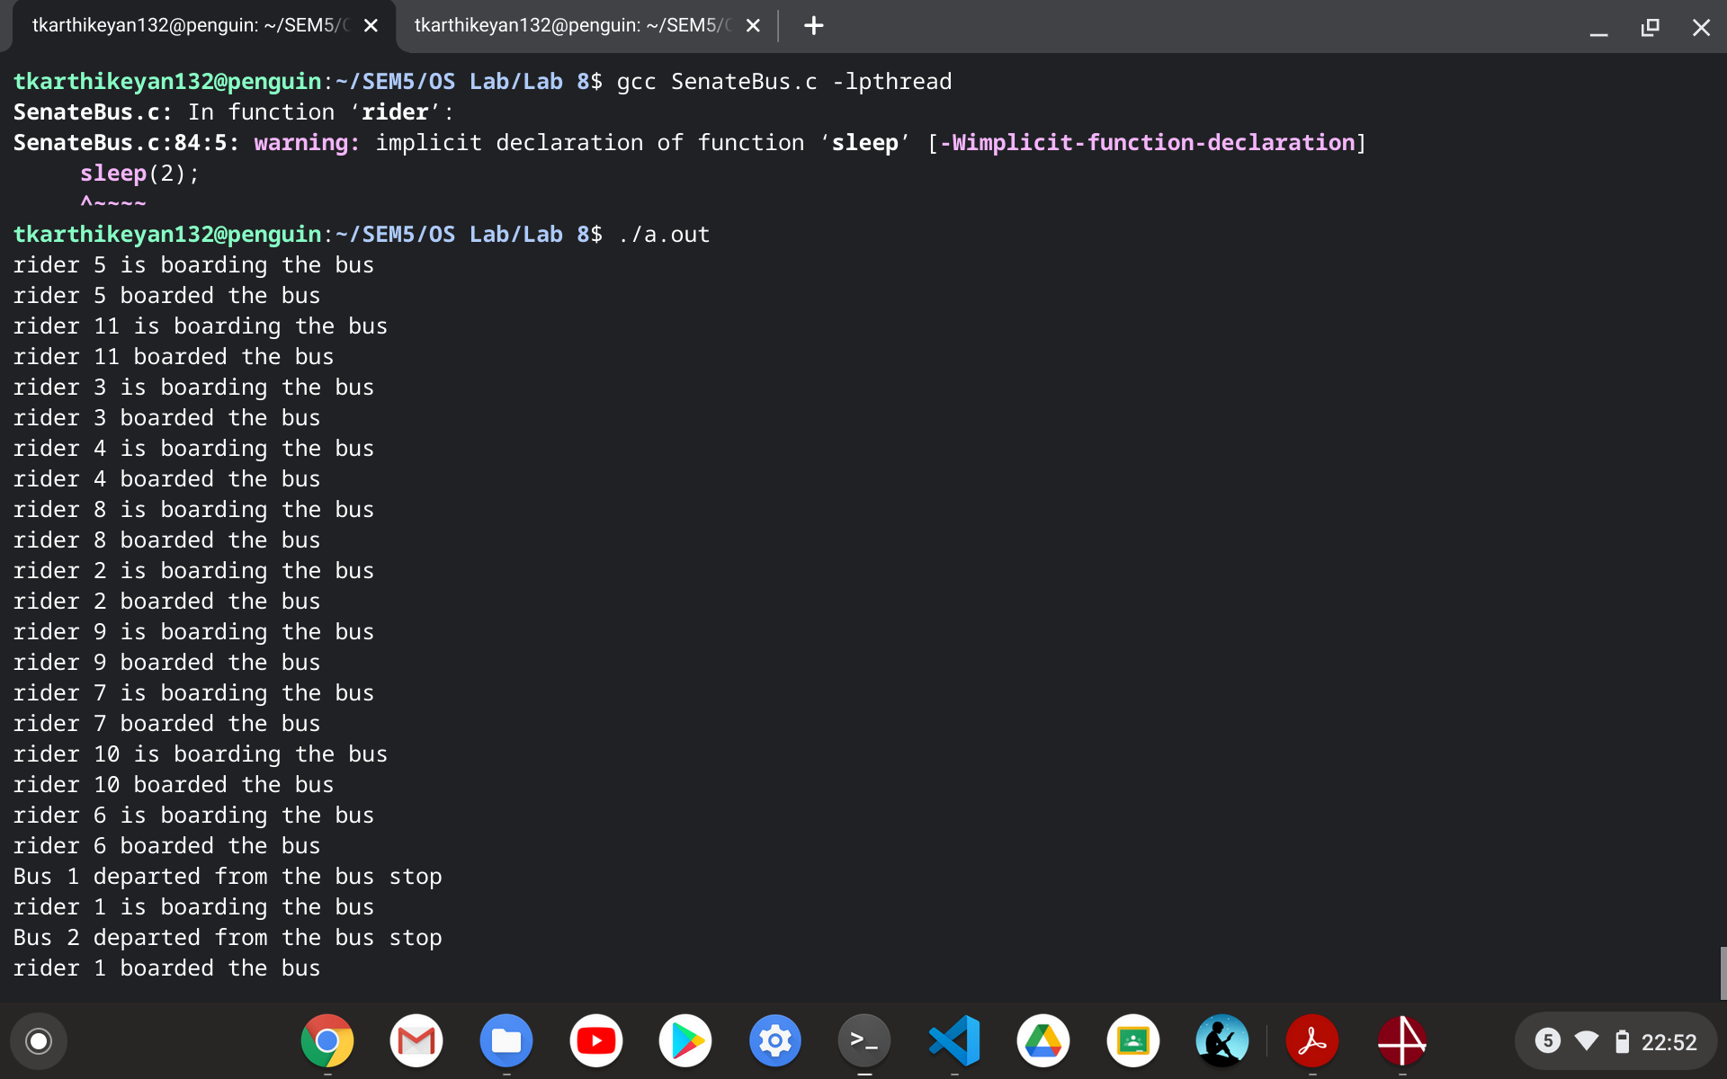

**Thanks**